The Road to Hope: Electric Cars, Clean Energy, and the Fight Against CO₂
In 2010, electric cars were barely visible in the global fleet - less than 0.01% of all cars. By 2024, they represent nearly 6% of global car stocks. According to projections, the world could reach 13% by 2030.
That shift isn’t just about technology - it’s about cutting CO₂ emissions, reshaping transport, and building a livable future.
The Global Trend
The story of electric mobility has shifted dramatically in little more than a decade.
- In 2010, adoption was almost zero.
- By 2024, electric cars accounted for around 6% of the global fleet.
- By 2030, forecasts suggest they could exceed 13% of all cars worldwide.
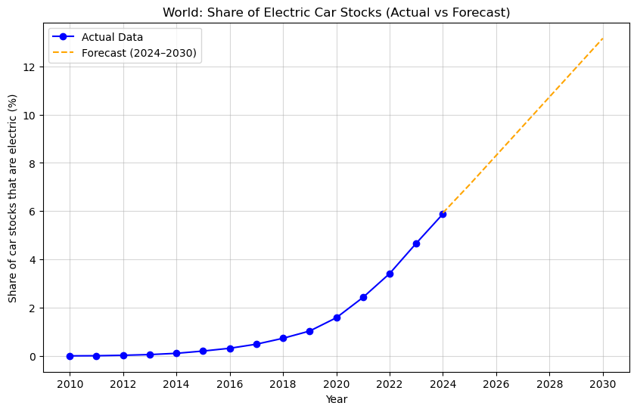
From niche to mainstream: global EV adoption set to double again by 2030.
Early Adopters: Pioneers of Change
Some countries embraced EVs early, crossing adoption tipping points years ahead of others.
- Norway: Leads the world with 32% of car stocks electric in 2024. Almost every new car sold there is now electric. With a grid powered almost entirely by hydropower, every EV in Norway delivers near-zero emissions per kilometre.
- Iceland (18%), Denmark (17%), and Sweden (13%) show how small nations can lead through strong incentives and renewable grids.
- Belgium, Netherlands, and China (all near 11%) have combined policy and scale to make EVs part of everyday life.
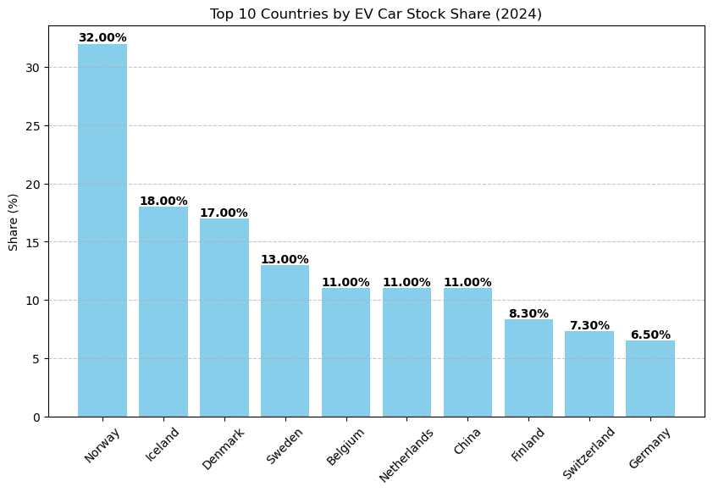
Late Movers: The Sprint to Catch Up
Not every country was first off the line. For many, electric cars remained a curiosity well into the 2010s. But once policy shifted and awareness spread, adoption curves bent sharply upward.
Brazil is the most striking example. From almost nothing a decade ago, its electric fleet has been expanding at a staggering 124.7% every year - the fastest growth rate in the world. What was once a hesitant market is now sprinting forward, doubling and tripling annually.
It isn’t alone. Greece, Turkey, and Mexico are writing their own acceleration stories, growing at nearly 80 to 95% a year. These are nations that only recently committed to the transition, yet are already catching up with early adopters.
Even countries better known for steady policy than sudden change - Finland, Chile, New Zealand, Israel, Italy - are now doubling their EV share every year. Their growth rates, ranging from 67% to 75% annually, show how quickly momentum builds once markets cross the tipping point.
What this tells us is clear: while early adopters may lead in sheer numbers, late movers can leapfrog into the future. For them, the transition is compressed - what took Norway two decades can happen in half the time.
When EVs Actually Matter
The real climate benefit of EVs depends on how the electricity is generated:
- In countries like Norway or Iceland, where electricity comes almost entirely from renewables, EVs deliver dramatic CO₂ savings. Driving electric there means virtually no lifecycle emissions beyond vehicle and battery production.
- In countries still heavily reliant on coal or gas power, EVs provide limited improvements, and in some cases can even match the emissions of efficient petrol cars if the grid is dirty.
- The turning point comes when EV adoption is paired with clean energy transitions - solar, wind, hydropower, nuclear. This is when EVs truly become the climate solution they are meant to be.
Why It Matters for CO₂
Transport as a whole is responsible for about a quarter of global CO₂ emissions, and road vehicles alone account for roughly three-quarters of that - around 15 to 18% of the world’s total. Cars, trucks, and buses are therefore central to the climate challenge.
Switching them from oil to electricity can deliver major reductions - but only if the electricity itself is clean. An electric car running on hydropower or wind is almost emissions-free; one running on coal-based electricity can still emit as much as an efficient petrol car. The climate benefit of EVs grows hand-in-hand with the decarbonization of national grids.
The impact is already visible. In the United States, studies show that raising EV adoption by just one percentage point - say, from 24% to 25% of cars - can avoid nearly 10 million tonnes of CO₂ each year. Scaled globally, every additional percentage point of adoption could prevent tens to more than a hundred million tonnes annually, depending on the size of the fleet and the grid mix.
In 2022, EVs globally avoided an estimated 80 million tonnes of CO₂-equivalent compared to a fossil-fuel baseline (IEA). If one translates that into ‘cars off the road,’ the figure is complex and depends on vehicle emission assumptions; Tesla alone claims over 20 million tonnes avoided for its fleet in 2023. Norway’s EV fleet alone achieves outsized savings because nearly all of its electricity comes from hydropower. If countries like Brazil, India, and Turkey scale EVs while also expanding renewables, the combined effect could reshape the global carbon cut all the years ahead.
A Story of Hope
Norway proves what’s possible with bold policy and clean power.
Brazil and Turkey prove late starters can accelerate faster than anyone imagined.
China shows the power of scale.
Together, these countries tell us one thing: the electric car revolution is real, unstoppable, and hopeful.
But the full promise of EVs only arrives when their growth is matched by the growth of clean energy. An EV plugged into a coal-fired grid may not move the needle. An EV powered by the wind, the sun, or rivers does.
Every EV added to the road is a promise:
- Cleaner air for children to breathe
- Quieter, healthier cities
- Fewer emissions heating our planet
The road ahead is electric - and powered by clean energy, the future is closer than we think.

